**This is our initial birdwatching mobile version (As a General User):**

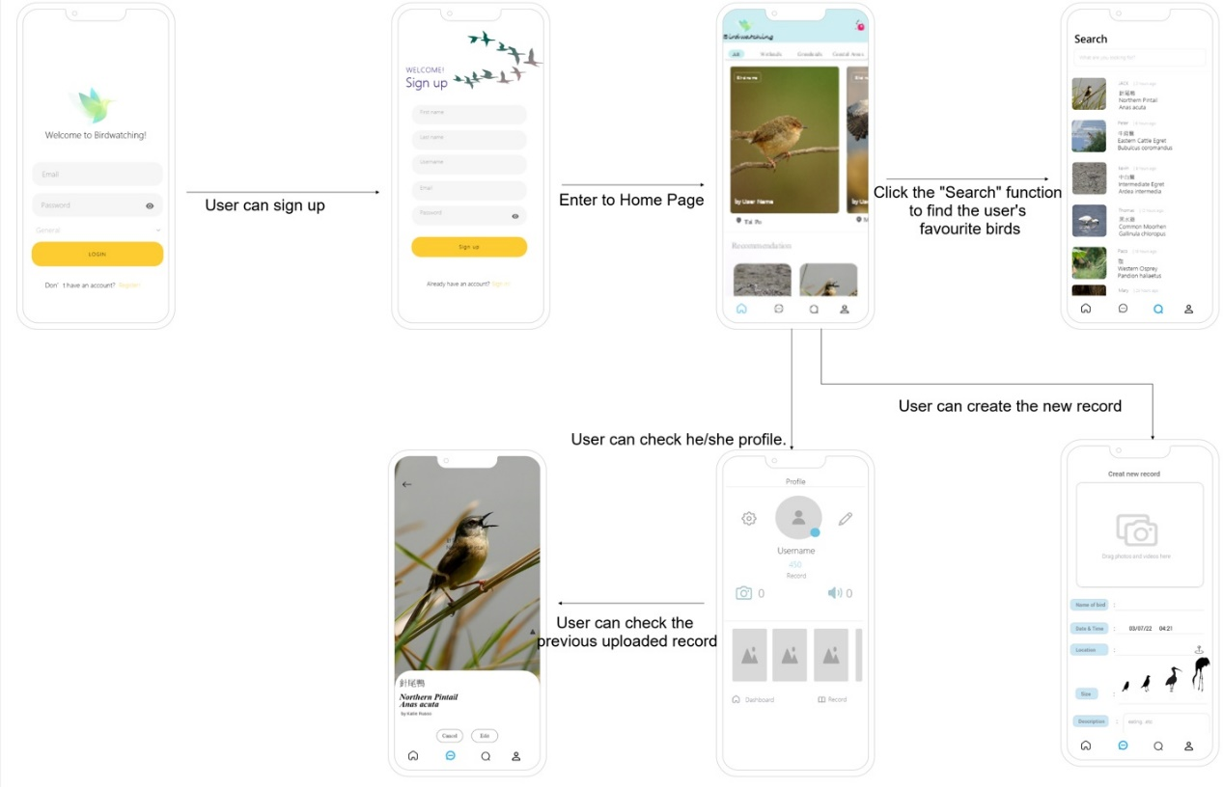

It defined to four users including General User, Expert User, Administrator and Modulator.

For General Use:

- it can sign up by himself/herself

- All records need to be approved by Modulator

For Expert User:

- It’s only created by Administrator

- All records can be uploaded by Expert, who also decide for public or not

- it will have a specific submit form (like e-birds)

For Administrator (Most authority)

- Can manage all user accounts

- Can manage all records

- Can create all user accounts

- Can manage all species list

For Modulator

- It just manages the records

**Login Page**

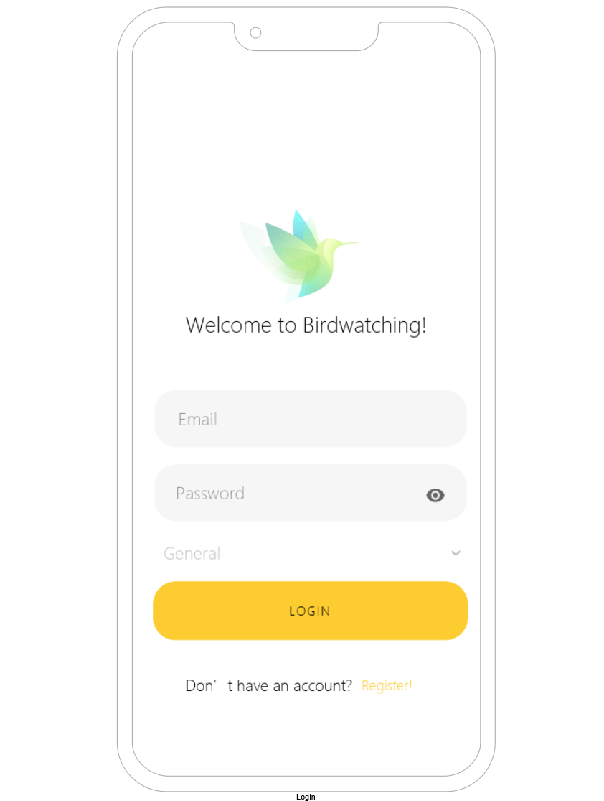

**Sign up**

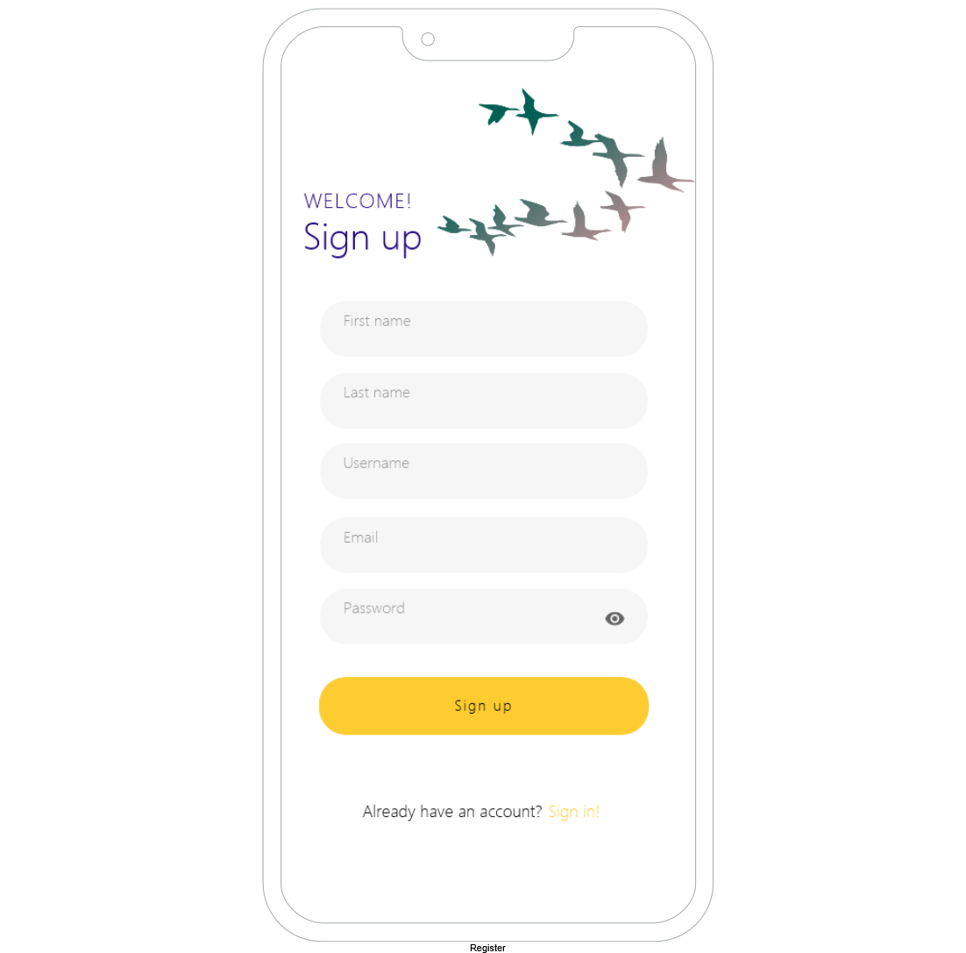

**Search**

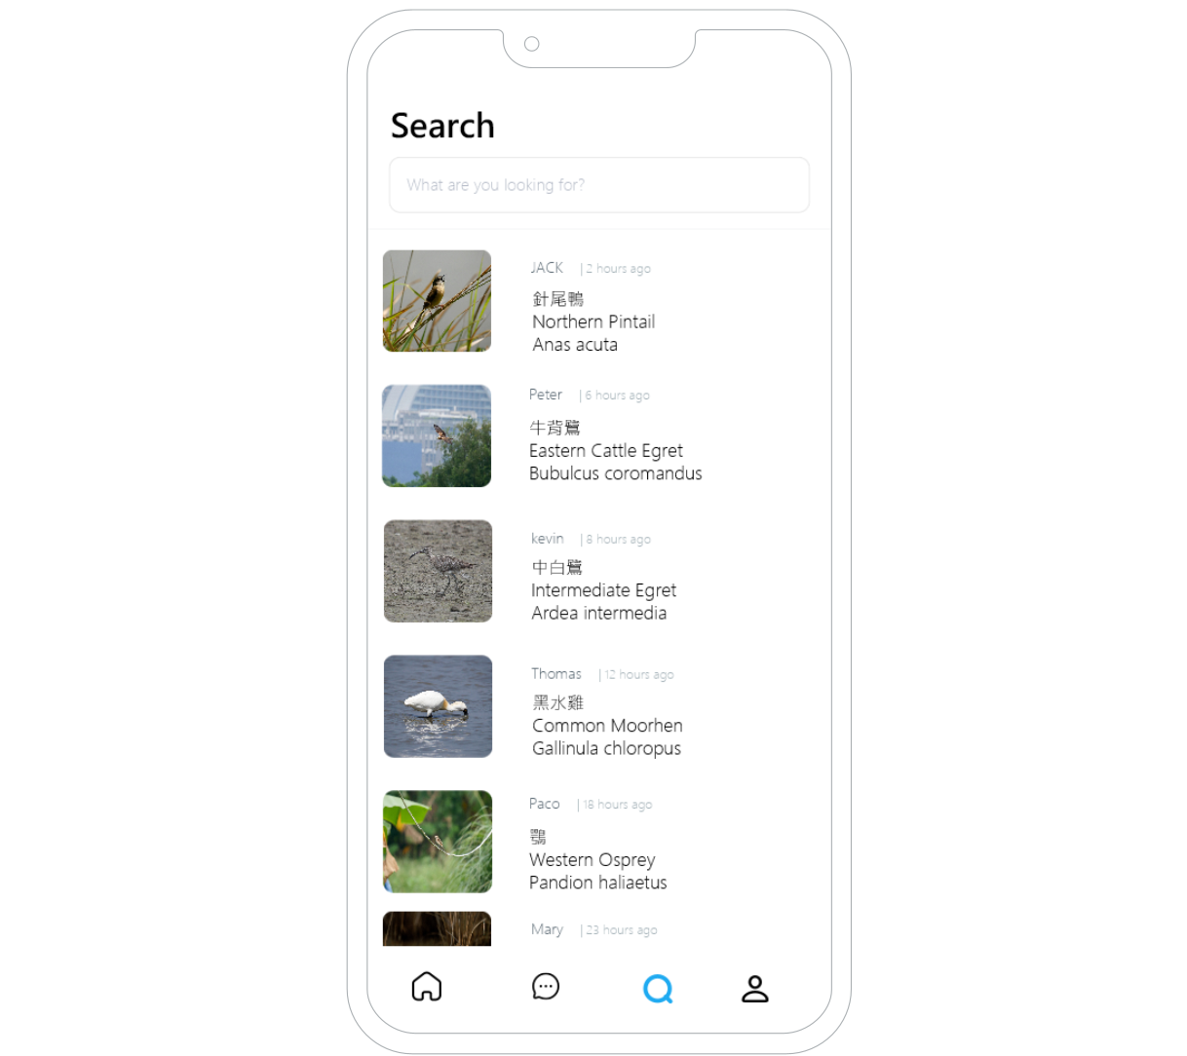

**Create new record**

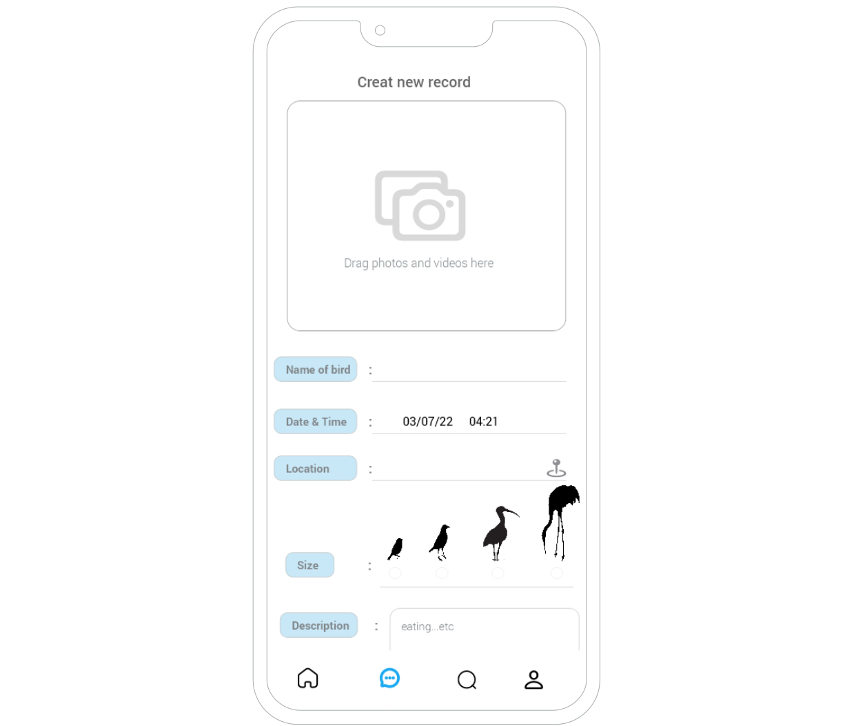

**Profile**

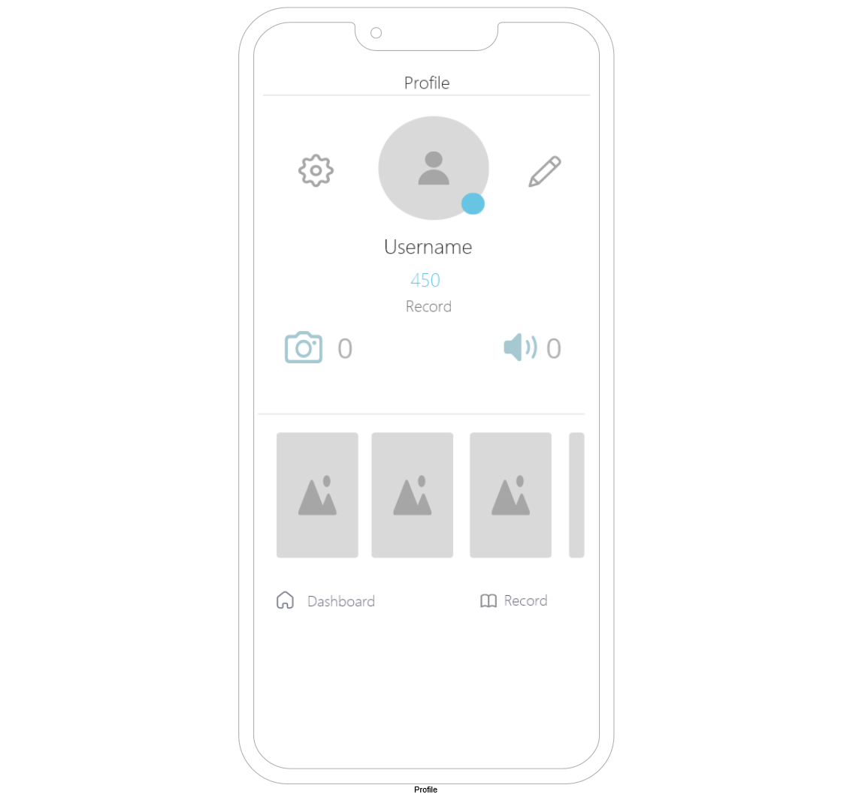

**Records**

